# **Fundamentals of Computer Programming (FOCP)**



Submitted by Submitted to

Rishav Rauniyar Krishna Sir

Section E, 8711

**Introduction to Programming**

Lab Worksheet

Week 1

**How to use the Python Interpreter**

**Starting the Python Interpreter**

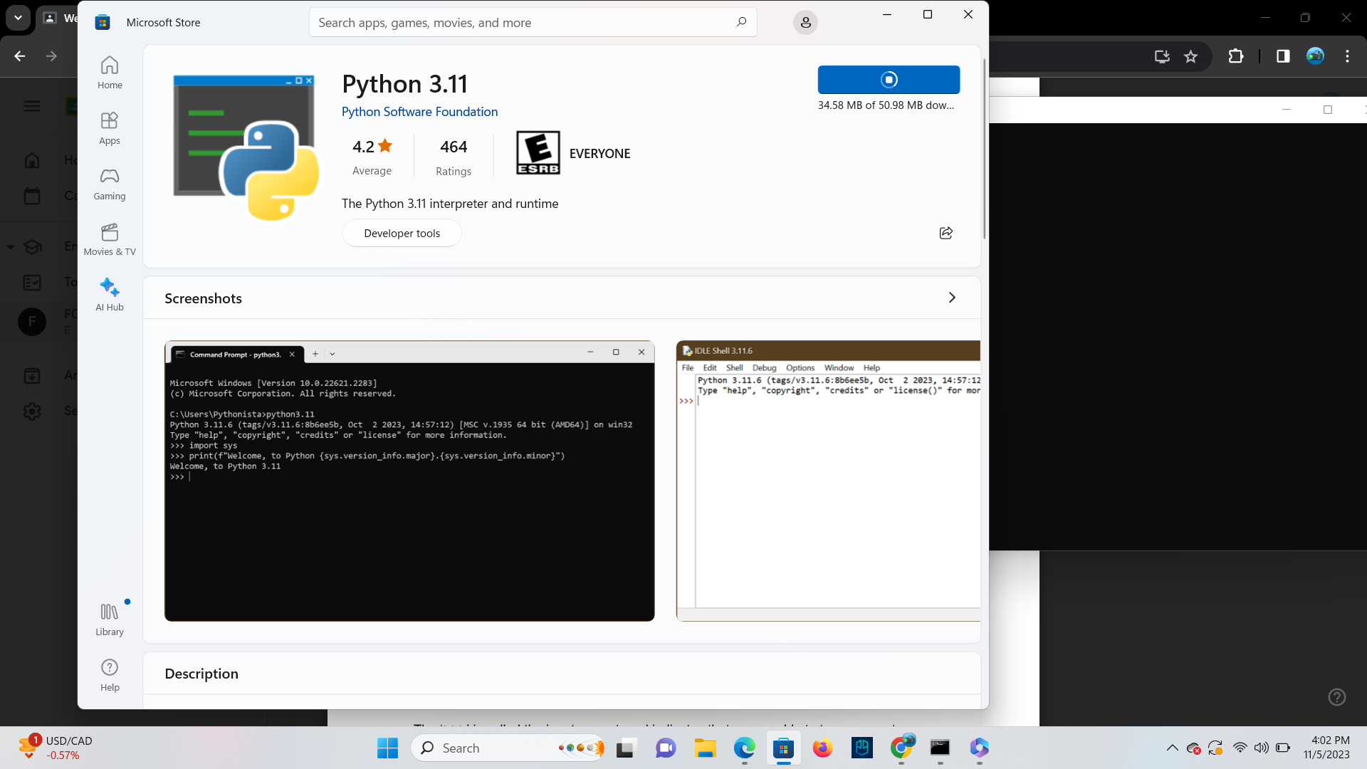

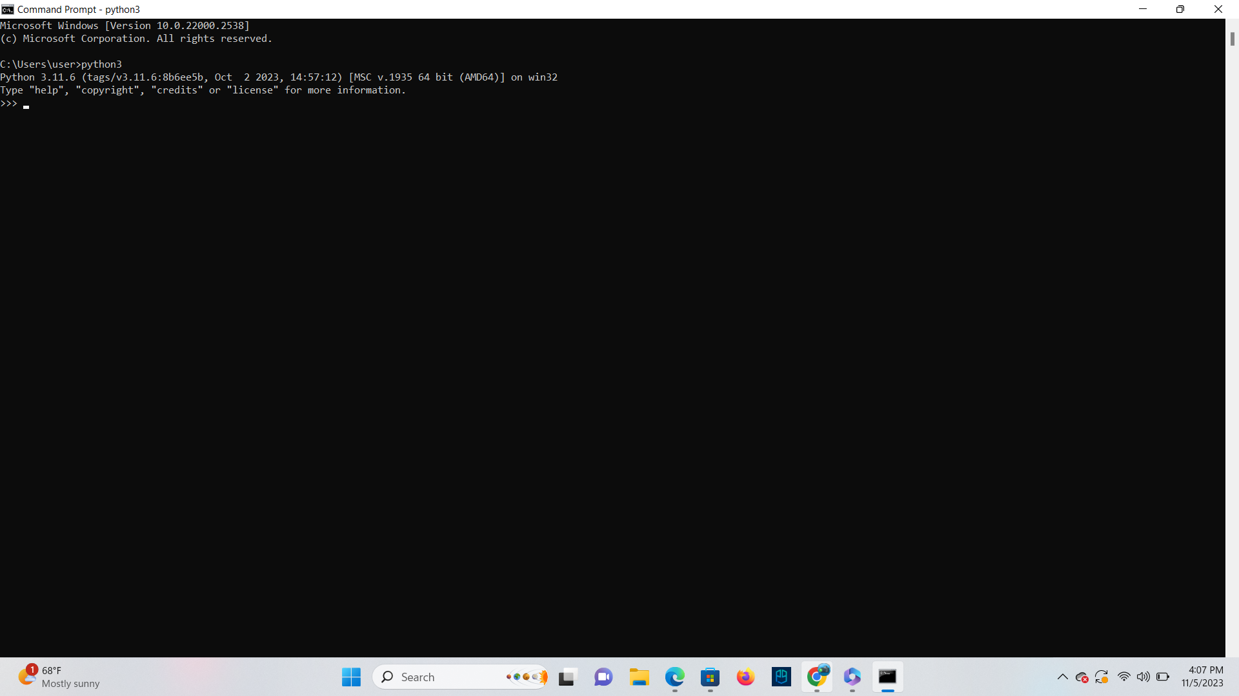

**TASK**: Try inputting and executing the code below.

If you run the above code correctly, the words **“the program has executed”** should

have been displayed. Make sure you are typing at the Python Interpreter (check the prompt).

**Ans**

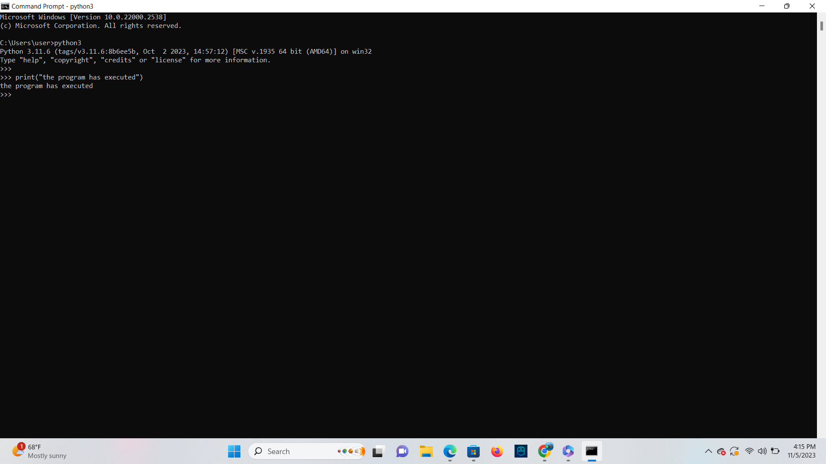

**TASK**: Try using a similar command to output at least three alternative messages.

**Ans**

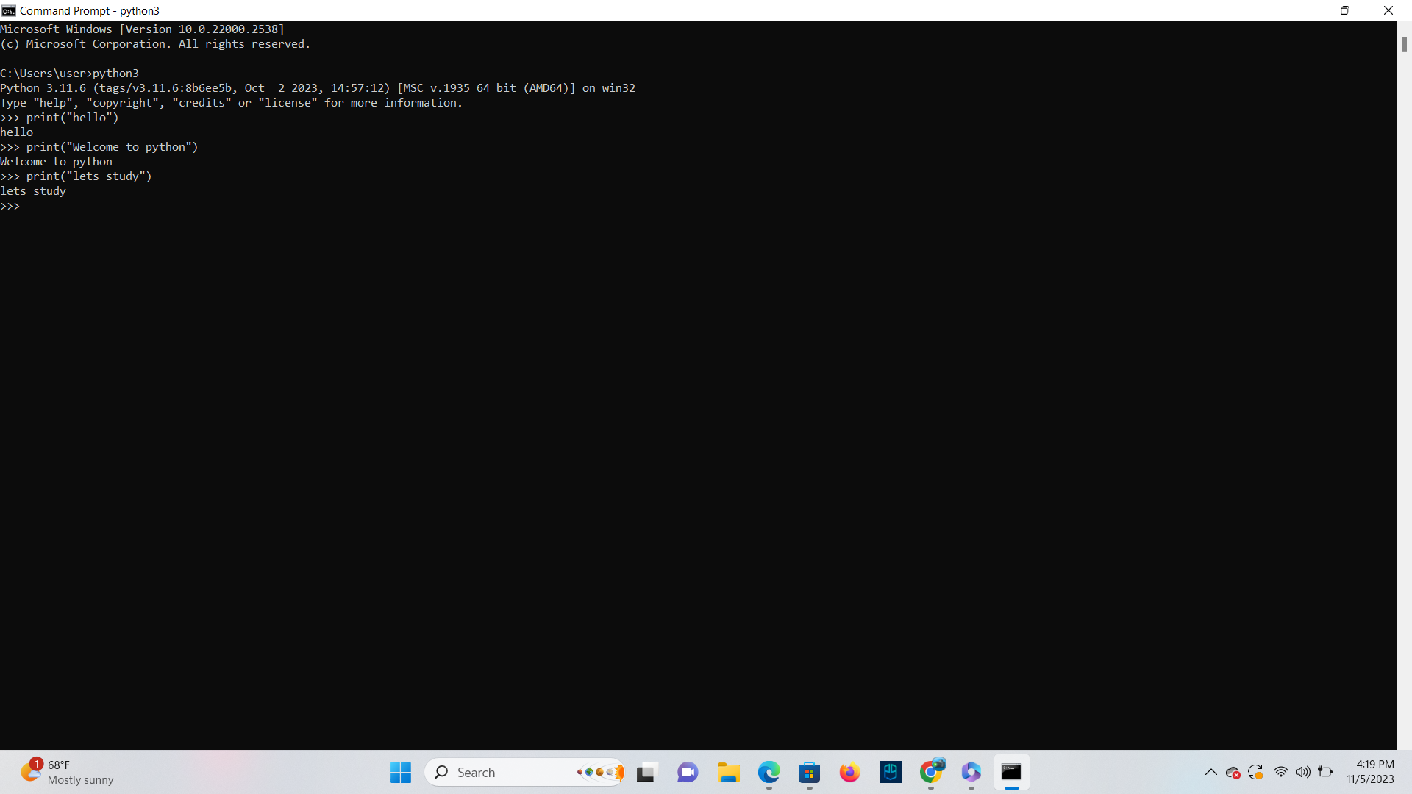

**Using command history**

**TASK:** Use the up and down arrow keys to recall the commands you have already input,

select one of these then re-execute the command by pressing the **<enter>** key.

**Ans**

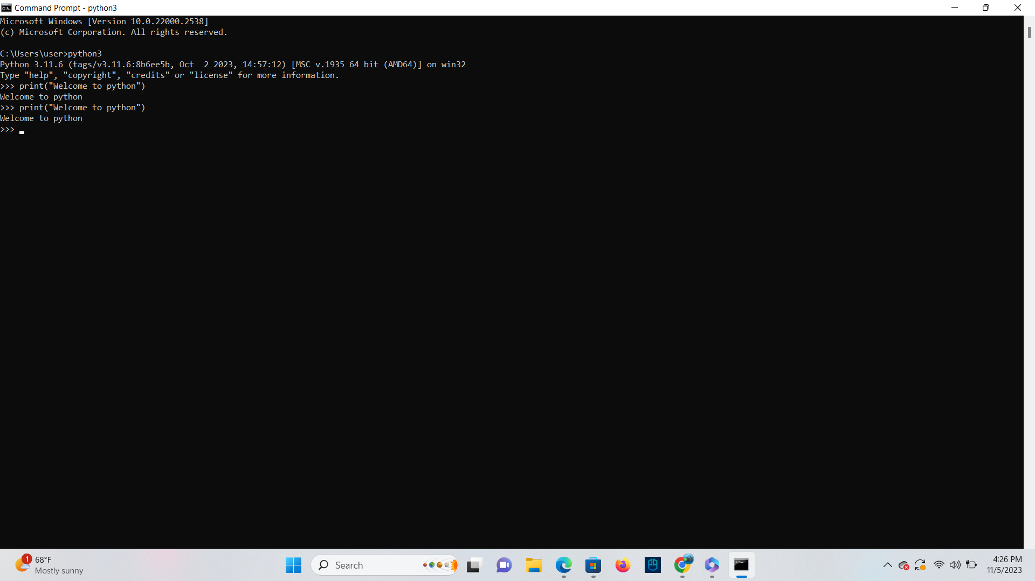

**Getting help**

**TASK:** Use the interactive help system to display a list of available language “keywords”,

then quit the interactive help to return back to the Python interpreter.

**Ans**

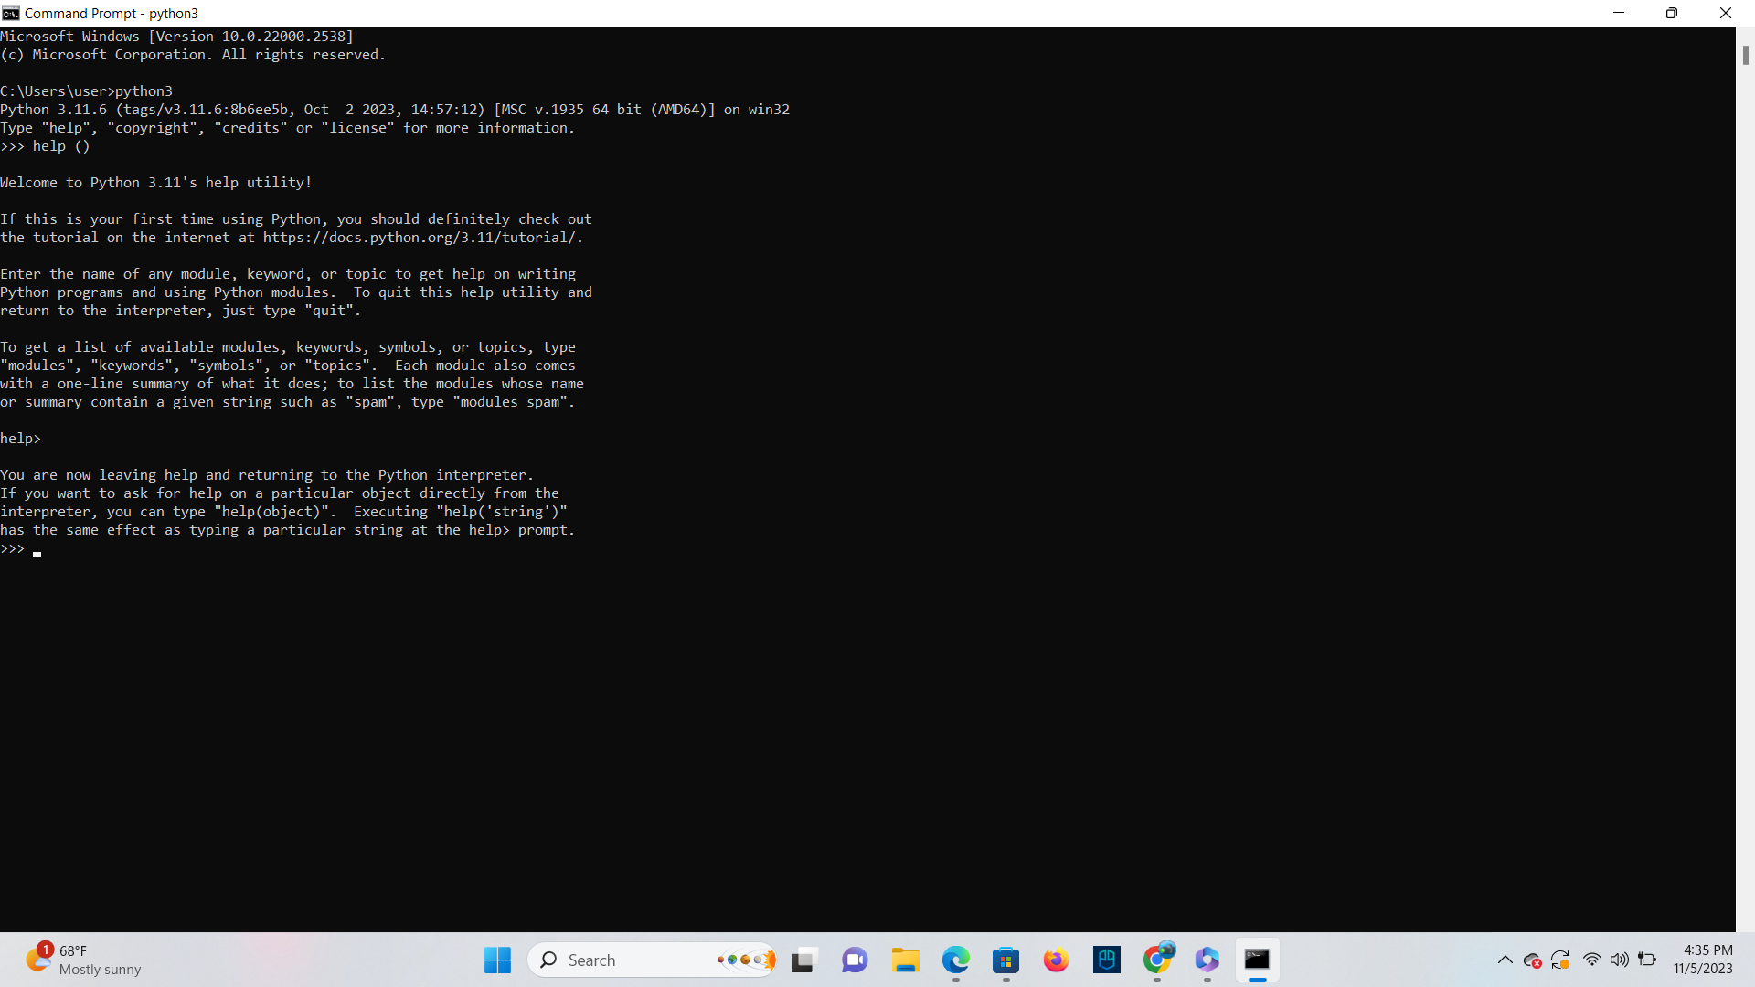

**TASK**:Enter a single ‘help’ command to look up information about the ‘input’ object then

return back to the interpreter.

**Ans**

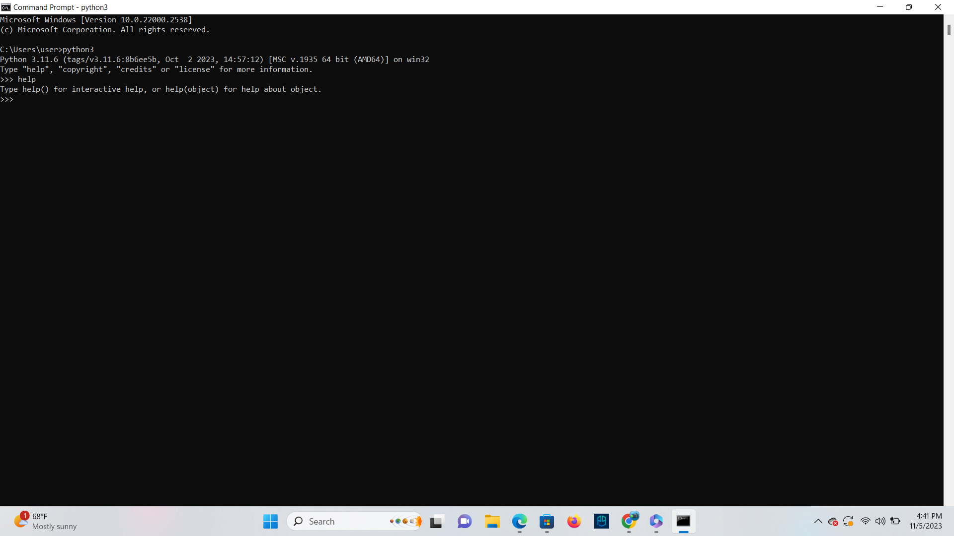

**Quitting the Python Interpreter**

**TASK**:Try quitting and then restarting the interpreter several times.

**Ans**

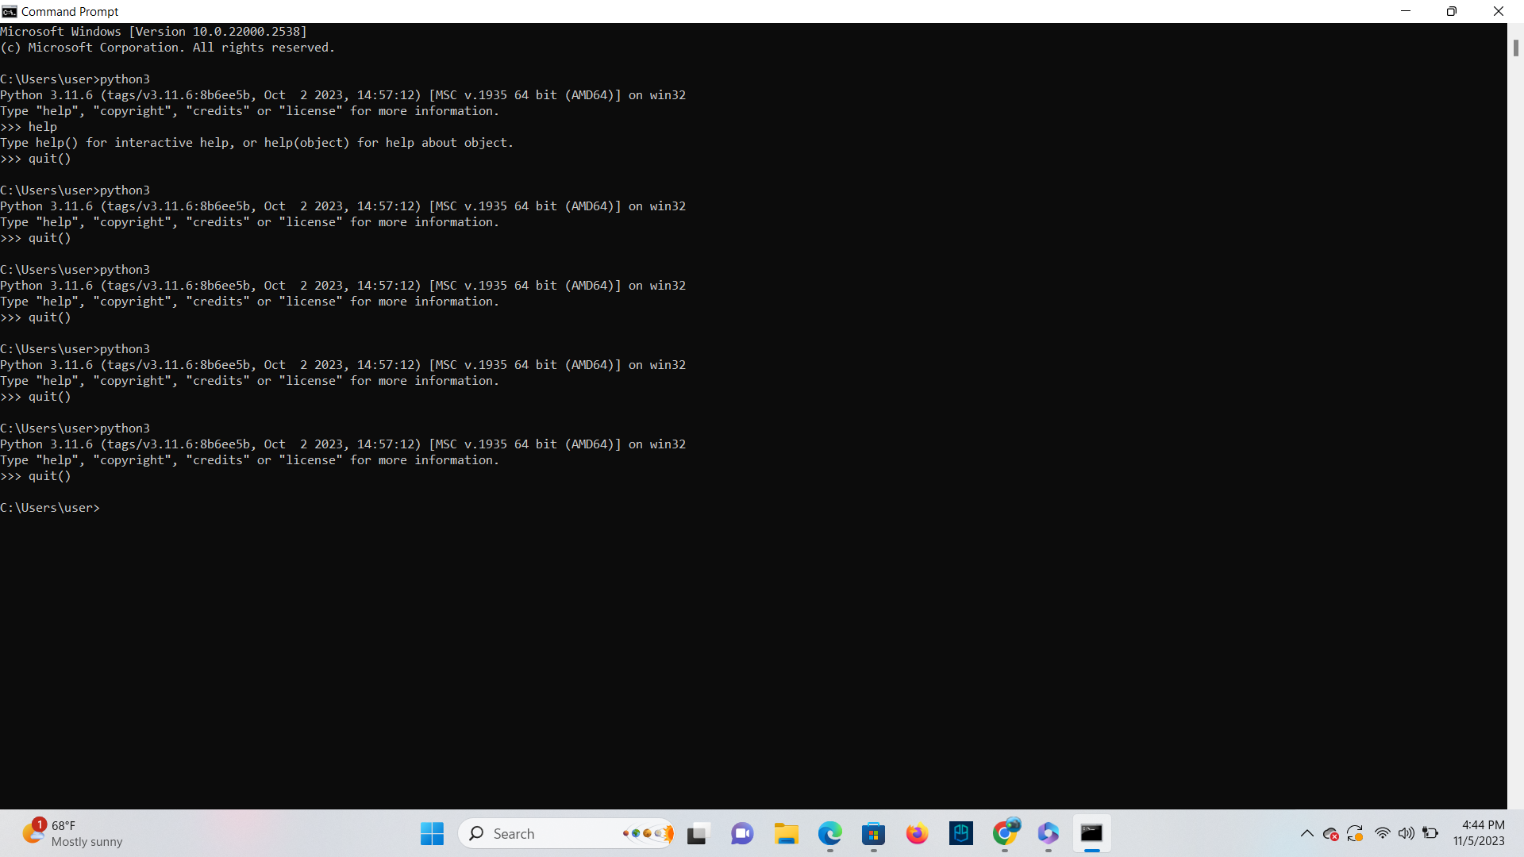

**Entering Basic Expressions**

**TASK**:Try inputting and executing the code below:

45+20

**Ans**

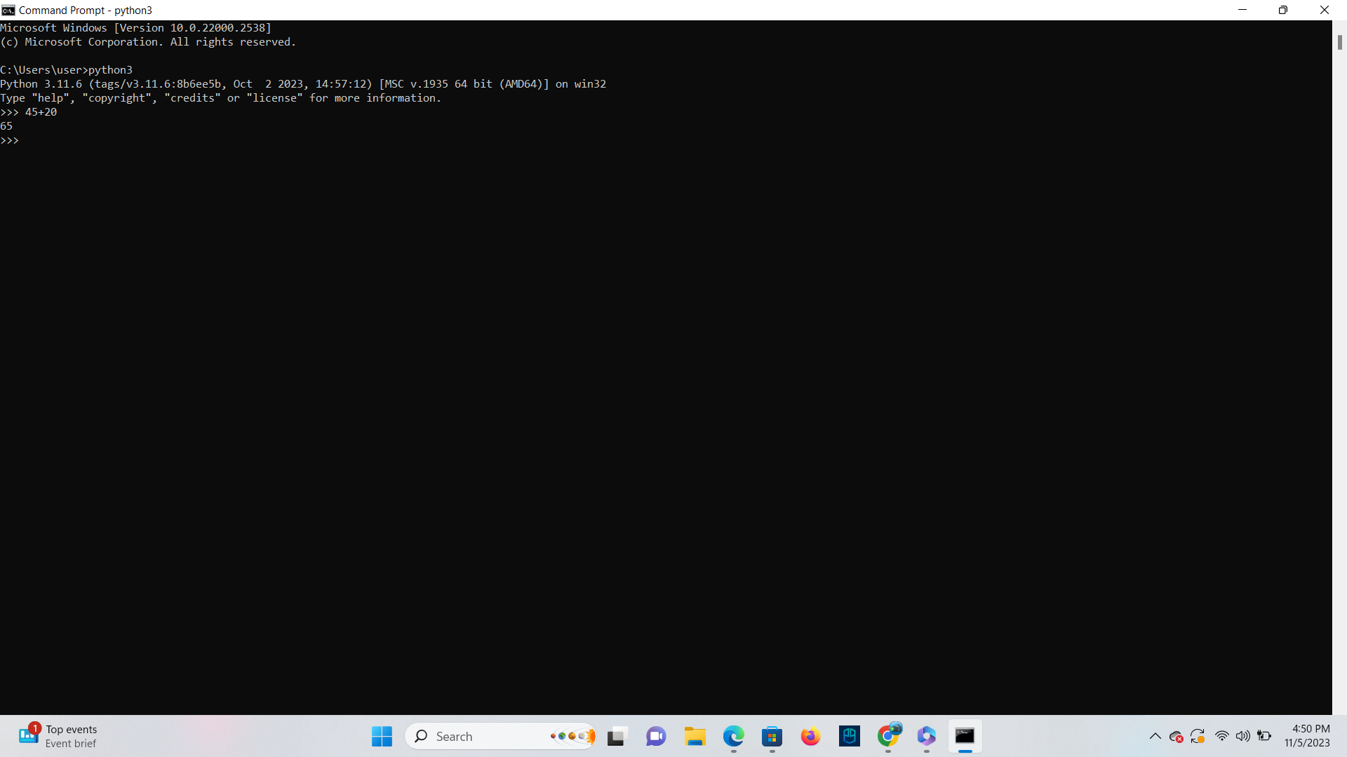

**TASK**:Input then execute the following expressions (note: you will have to re-enter each

expression separately). Ensure you understand each operator and the result produced.

10+20-15

10*5

100/33

100//33

**Ans**

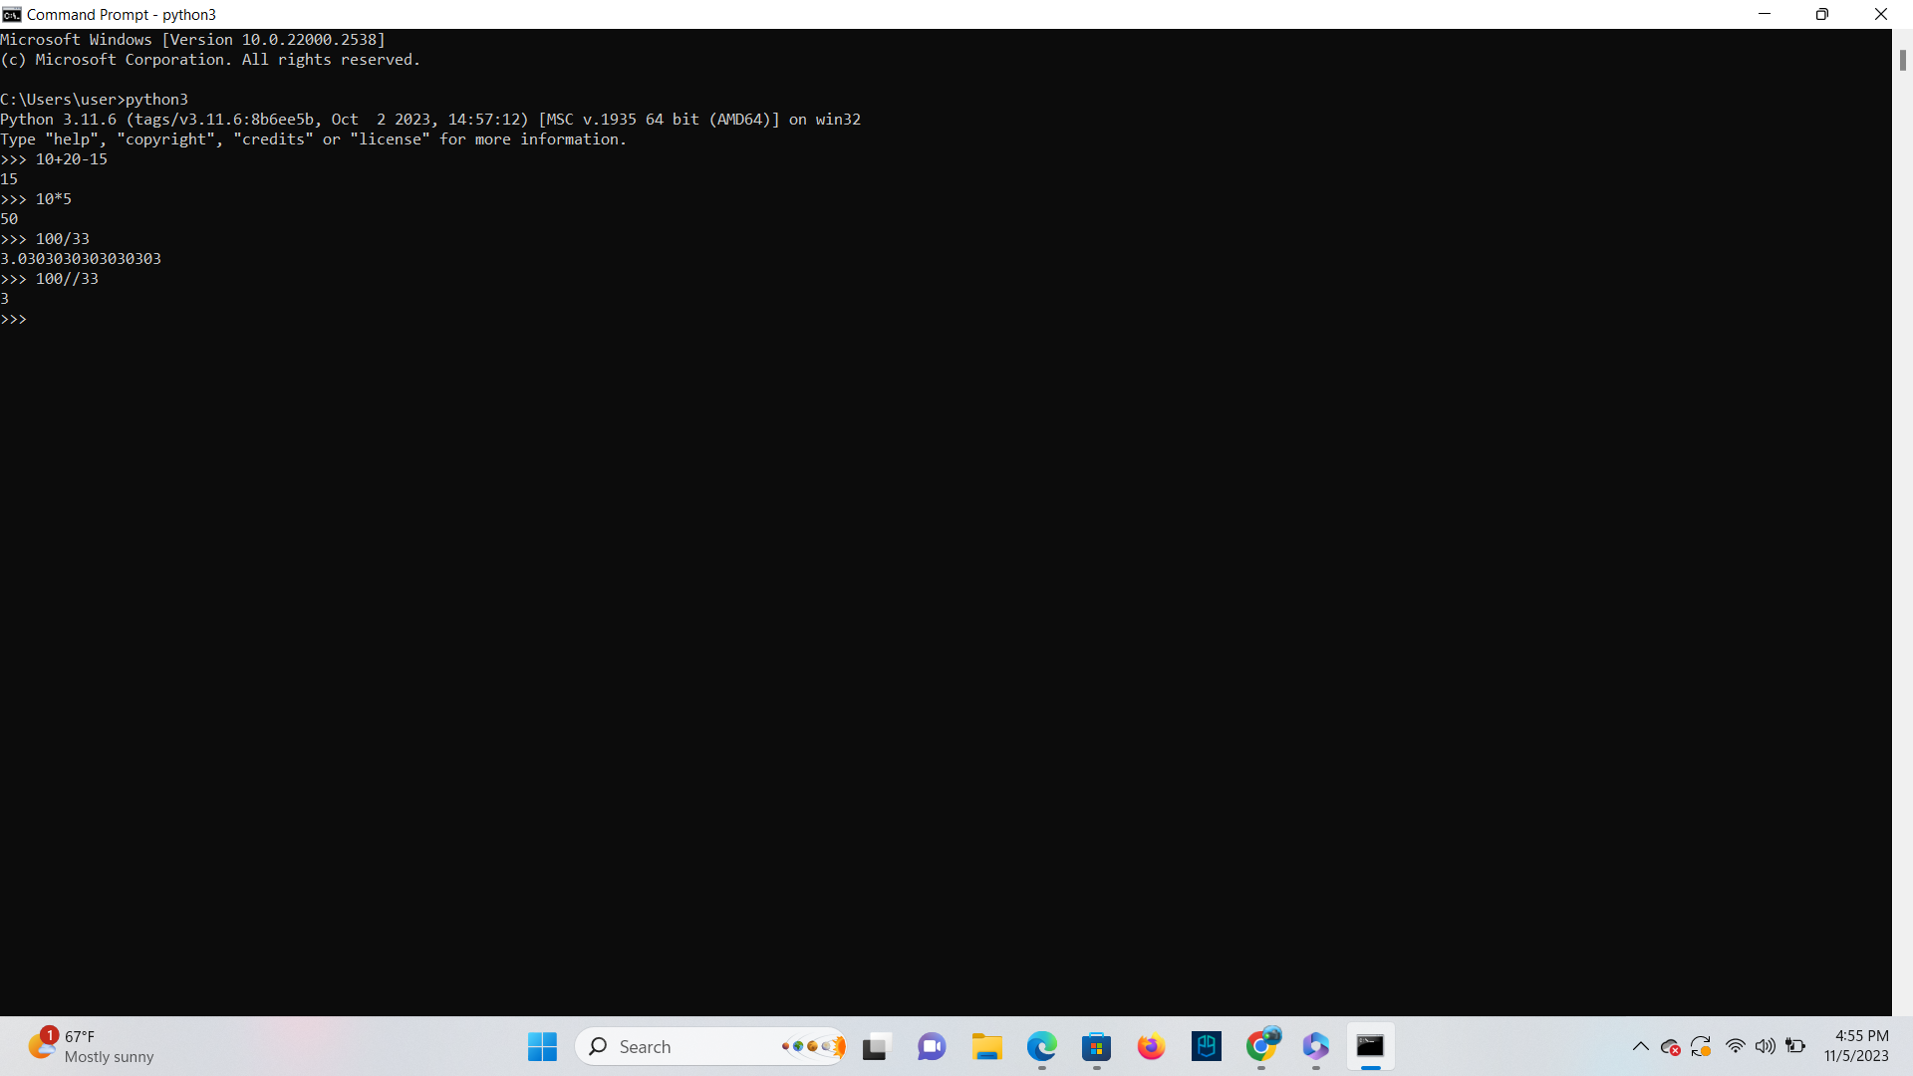

**Operator Precedence**

**TASK**:To see precedence at work input then execute the following expressions.

10+5*2

10-5*10+5

5*10**2

**Ans**

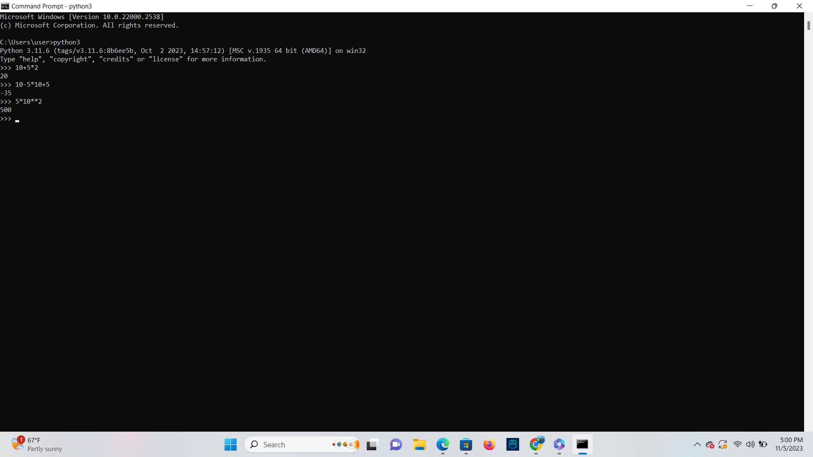

**TASK**: Input and execute the following expressions, then compare the results to those of the

previous task.

(10+5) *2

10-5*(10+5)

(5*10) **2

**Ans**

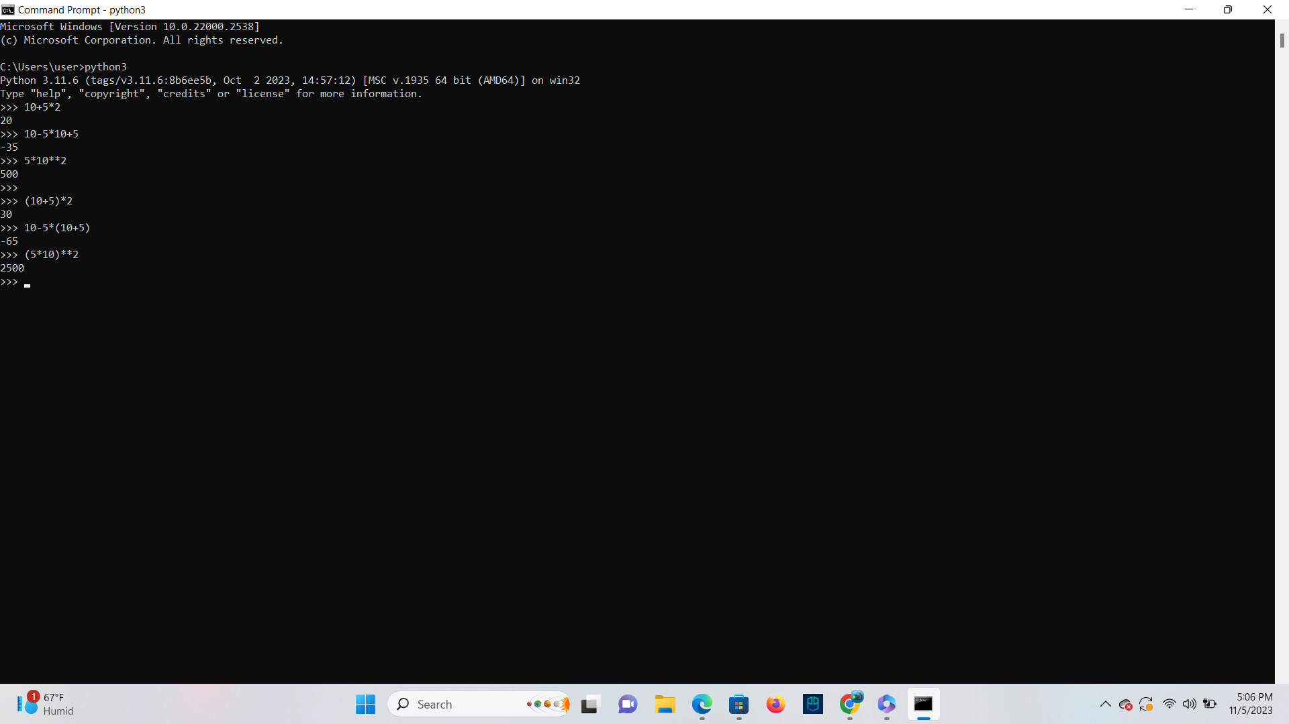

**TASK**: Input and execute the following expressions. Notice the different results.

12 + (5 * 2 + 3)

12 + (5 * (2 + 3))

**Ans**

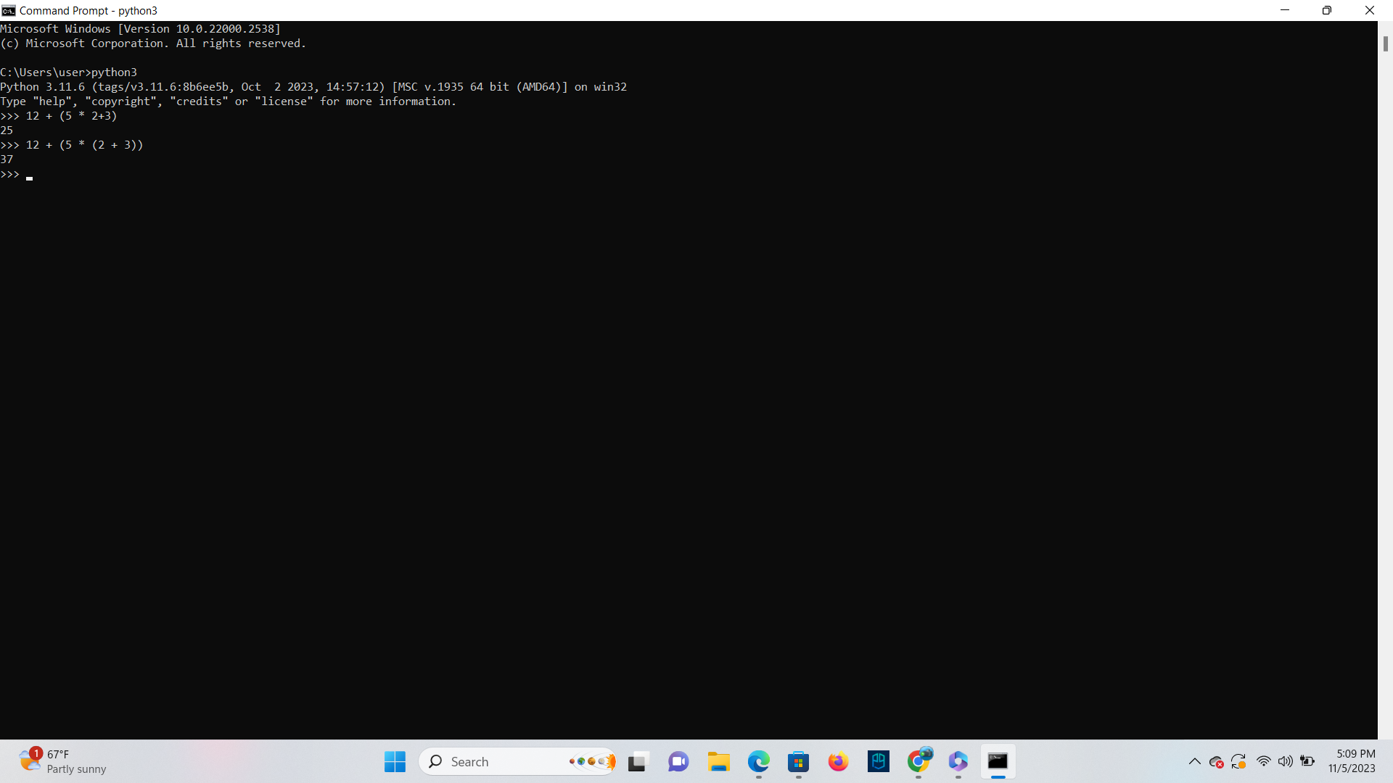

**Errors**

To see a typical example of a syntax error being reported, input and execute the following

code:

10+

**Ans**

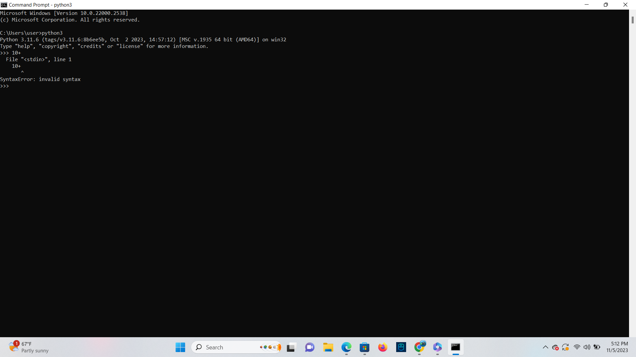

To see a typical example of a run-time error being reported, input and execute the following

code:

print (“Ten divided by zero is”, 10/0)

**Ans**

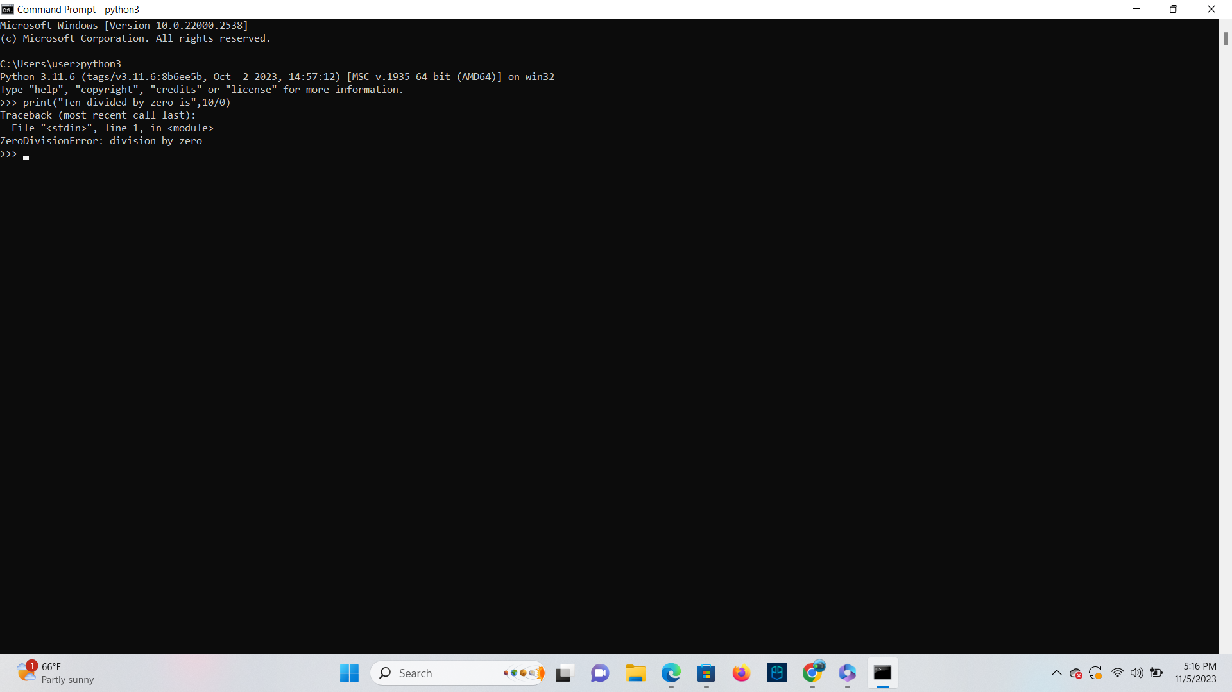

**Key Terminology**

**TASK**: Look at each of the phrases below and ensure you understand what each of these

means. For any that you do not understand, do a little research to find a definition of each

term. This research may involve looking back over these notes, or the associated lecture

notes. It may also involve searching for these terms on the Internet.

**● Source code**

**Ans** Programming statements that are created by a programmer with a text editor or a visual programming tool and then saved in a file.

**● Machine code**

**Ans** It is a computer code consisting of machine language instructions.

**● Interpreter**

**Ans** Itis a computer program that directly executes instructions written in a programming or scripting language.

**● Compiler**

**Ans** A computer program that translates code from a high-level language into machine code.

**● 2GL, 3GL, 4GL**

**Ans** Second generation languages involved assembly languages.

Third generation languages are the most used, they include C, C++ and Java.

Fourth generation languages are more abstract from the underlying machine, and are based on defining what is to be done, rather than how

**● Executable**

**Ans** Acomputer file that contains an encoded sequence of instructions that the system can execute directly when the user clicks the file icon.

**● Expressions**

**Ans** It is a value, or anything that executes and ends up being a value.

**● Operators and Operands**

**Ans** 45 + 20

In this example the operands are the numbers 45 and 20 and the operator

is the +

**● Syntax Errors**

**Ans** These errors occurs when syntax has not been used properly.

**● Logical Errors**

**Ans** These errors occurs when a program is syntactically correct, but the underlying algorithm was incorrectly designed or poorly implemented.